Overviewing Technological Impact on Construction Industry

Nitin Athavle
General Manager,
Rachana Lifestyle ______________________________________________________________________________
Present scenario: The requirements of the customer (first time buyer & second time buyer) are continuously changing with changing times. The real Estate and the construction industry as well is undergoing and experiencing speedy and radical changes in the business eco system.
There are a number of emerging technologies in the construction industry that are playing an important role towards shaping its present towards the future. The factors impacting this change, including the following:
- New sustainability and green building bench markings: Technologies like IOT, AI, Robotics, 3D printing, modular construction, solar panels, energy efficiency measures and smart homes are becoming increasingly popular among Real Estate developers as they focus on sustainable development.
- Augmented Reality (AR) and Virtual Reality (VR): Augmented & Virtual Reality are now creating immersive customer experiences which give architects unprecedented insight into their designs before any physical work gets started - this helps designers accelerate timeliness, ultimately saving money and materials throughout the entire process.
- Data Driven Organizations: New & emerging data-driven enterprises prefer to follow the leaner project making with the help of AI & automation tools to drive efficiencies during key project stages — starting with preconstruction activities, during operation & maintenance procedures, project completion, and post-project delivery stage, by providing detailed analysis on cost efficiencies coupled with output gains enhanced by digitalizing solutions like preventative maintenance routines using predictive analytics.
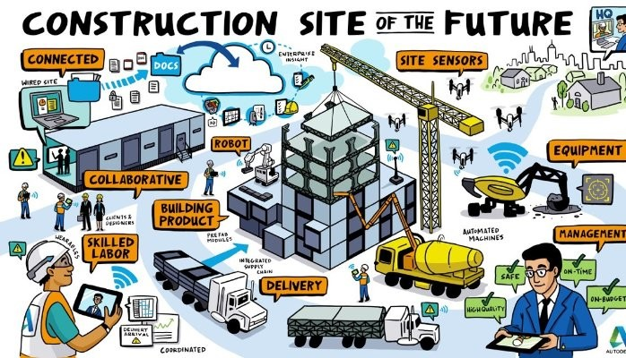
Connectivity- A major game changer: ‍To make all these technologies perform well, there is a sudden rise in demand for uninterrupted and seamless flow of “Connectivity”. The scope extends from interconnectivity between multiple devices, systems or establishing reliable connectivity in remote work areas, or providing a strong internet network which is essential for controlling, monitoring and managing Construction technologies & related solutions.
By embracing these Construction technology trends, organizations can stay at the forefront of innovation, overcome challenges and achieve greater efficiency, productivity and safety in their Construction projects.

Top Emerging technologies in construction industry: The construction industry has been agile & resilient towards embracing technologies to adapt to changing times, investing in digitalization, supply chain control and safety technology.
With these technologies the organizations are able to bring considerable change in the improving the working conditions, boost efficiency level, , enhancing towards better health and safety measures and offer various other benefits.

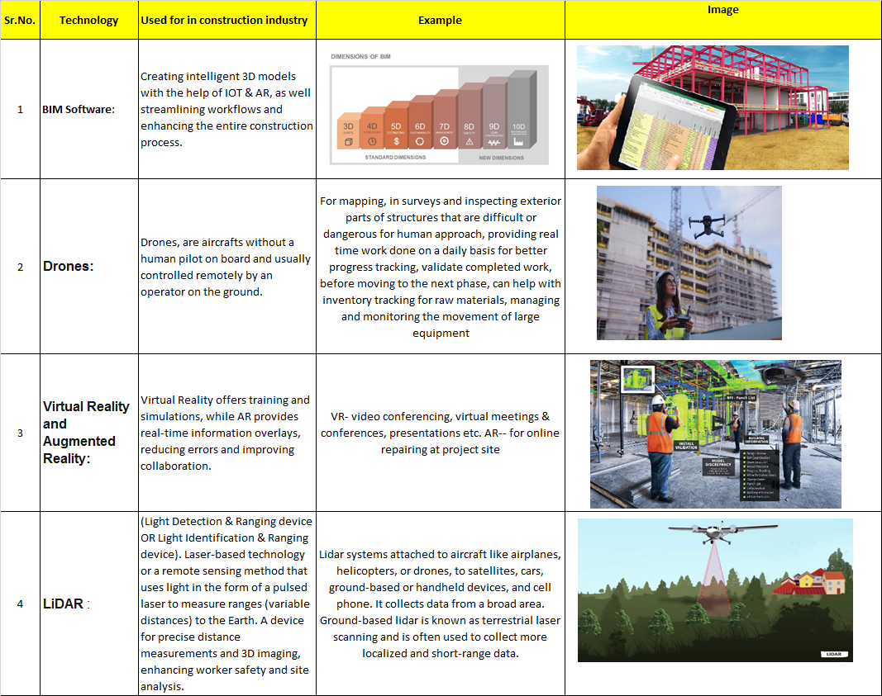
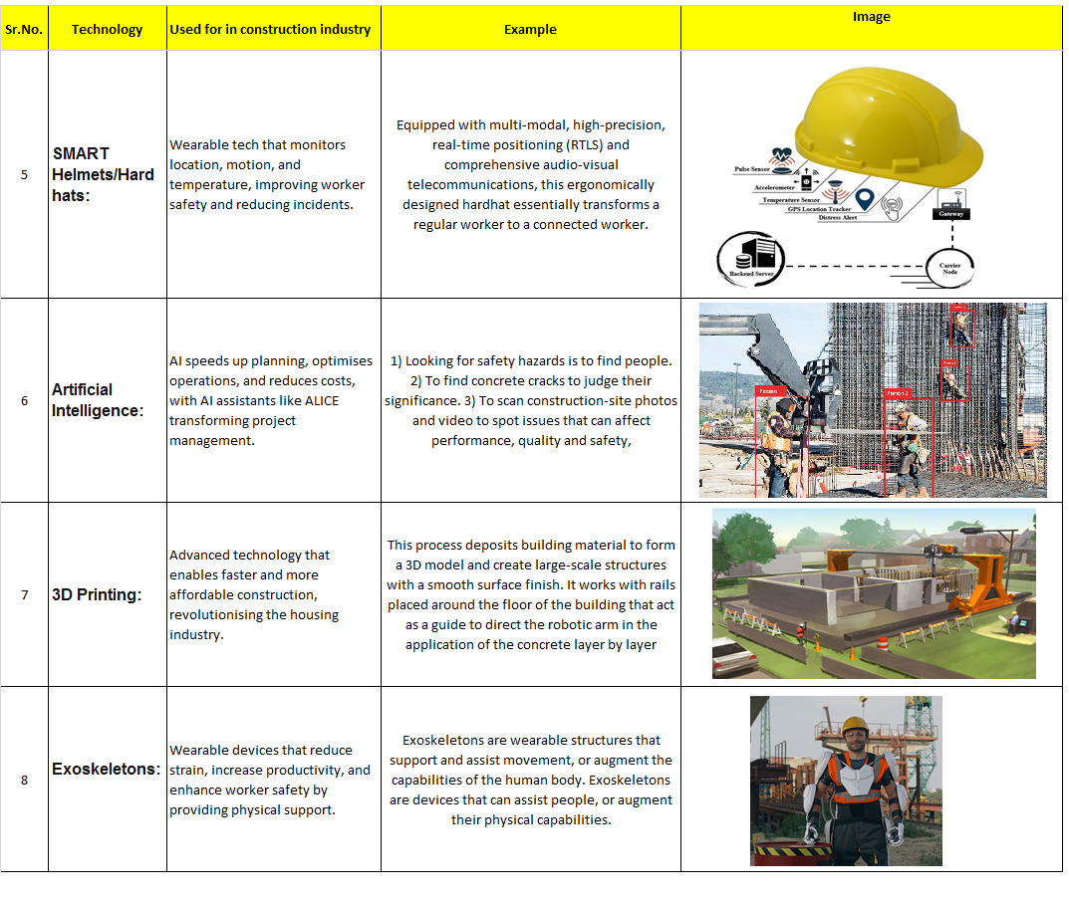

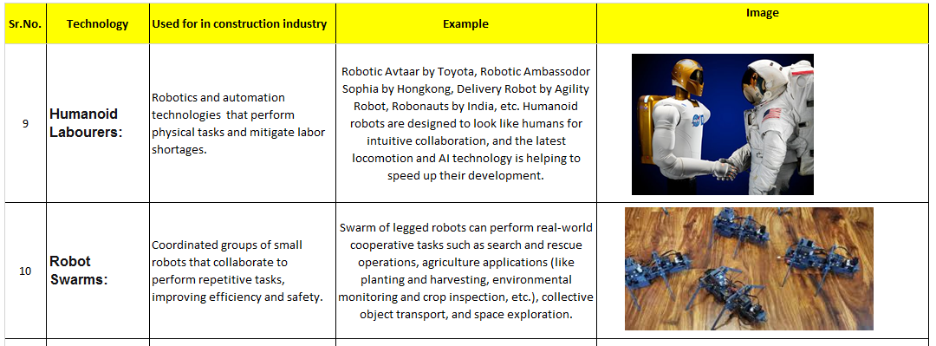
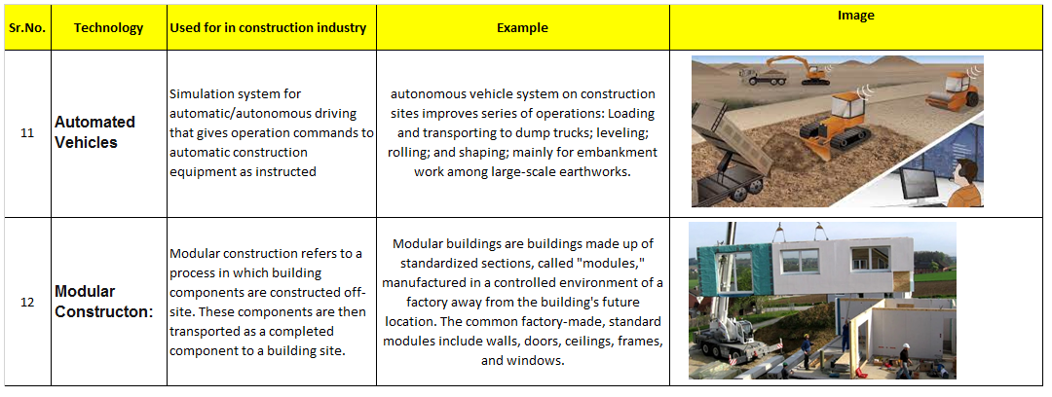

Present Risks & Challenges faced by the construction Industry:
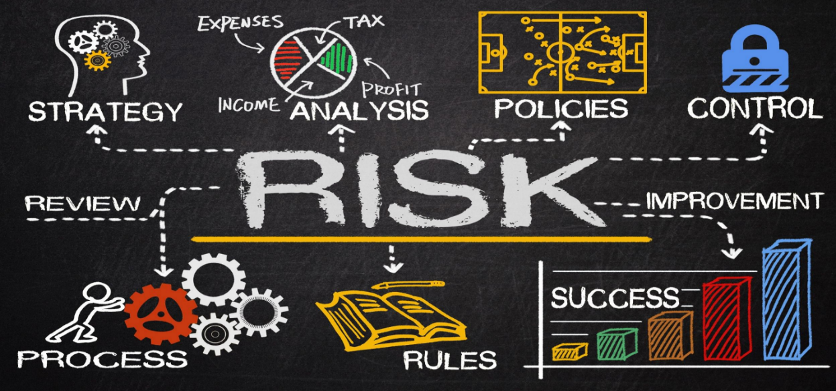
- Inadequacy of skilled workforce: The technologies are changing with high speed and pace of time, but the present work force needs to embrace to adopt these technologies.
- High Investment Cost: To incorporate all the new technologies the small and medium construction company needs to fetch in more amount to invest, which itself impacts the bottom line.
- Priority: The enterprises operating on a small or medium scale would really find it difficult to bring these technologies as highest point of priority in the agenda.
- ROI: Every small and medium Construction enterprises will all the time more concerned about the Return on Investment put for these high end technologies.
- Impact on present ongoing sites: By the time the new technologies get enrolled in main stream of site execution, there are possibilities of existing work getting delayed or sidelined for incorporating new technologies.
Solutions to mitigate the Risks /Challenges: After reviewing the major concerns, now it becomes more crucial to address these challenges. This is possible through identifying the root causes of project delays, cost over-run, underutilization of equipment’s at construction sites etc.
Solution suggested:
- Talent & Up skilling: The construction companies need to identify the skill gaps and required talent to the present and future employees.
- Funds allocation: Looking at the present constraint the stake holders can definitely think of crowd funding and prioritizing the spending’s.
- Embracing new technologies: Suppliers, Contractors, owners, other channel partners need to adopt, adapt the new technologies in the business environment.
- Involve, & Evolve through collaborative efforts of all the concerned involved to make the supply chains stronger, larger and efficient.
- Prioritize only few investments instead of focusing on the cluster of opportunities.
- Transparency/Traceability/Visibility in all the transactions carried out within the construction sites as well with the external business environment.
Conclusion: To stay ahead and sustain into the ever changing environment the project owners, contract managers, top executives, material suppliers, shall now stay up to date with the current industry trends & insights.
For further queries & feedback: write to
Nitin Athavle
athnit2@gmail.com
9423013272

