Metaverse in Logistics

Nitin Athavle
General Manager,
Rachana Lifestyle, Pune

Overview: The Indian logistics industry is growing, due to a flourishing e-commerce market and technological advancement. The logistics sector in India is predicted to account for 14.4% of the GDP. The logistics sector in India was valued at US$ 250 billion in 2021, with the market predicted to increase to an astounding US$ 380 billion by 2025, at a healthy 10%-12% year-on-year growth rate.
Logistics and Warehousing sector: Modern warehouse facilities and technology-driven solutions have changed the warehousing sector in India in recent years. With increased demand and supply throughout the years, the Indian warehousing industry is gaining traction. A warehouse is an essential component of corporate infrastructure and one of the primary enablers in the global supply chain. the Indian warehousing market is predicted to reach US$ 34.99 billion (Rs. 2,872.10 billion), expanding at a CAGR of 15.64% from 2022 to 2027.
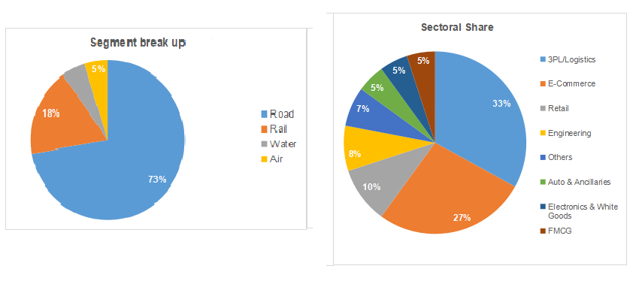
Technology in smart Logistics: The supply chains can utilize the latest technologies, such as data analytics, to gain insights into different aspects of a business. For instance, with proper systems, a business owner can track product sales, categorize products into fast- and slow-selling goods, and obtain region-wise details.
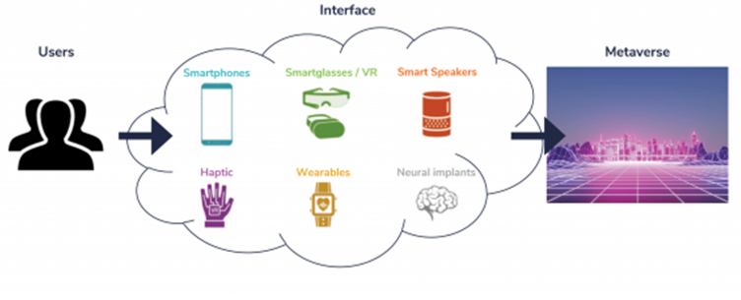
Metaverse a solution to Supply Chain - Logistics: They collaborate on demand forecasting, inventory management, and logistics planning, fostering transparency and agility in the supply chain. The metaverse enables real-time communication and coordination, minimizing delays, improving responsiveness, and enhancing overall supply chain performance.
The design of the metaverse aims to have a virtual universe where everyone can interact as in the real world. Thus, players will be able to make purchases or trade in this world. It adds prestige and value to this supply chain. The metaverse is even economically independent.
Integration with IOT improves logistics performance: The Internet of Things (IoT) can be a game-changer for the logistical requirements of MSMEs. IoT works on collaborating real-time data with intelligent algorithms that provide inputs on road/traffic conditions, carriage performance, and other challenges faced in the supply chain process. This implies that a business has enough information to choose better delivery routes while considering distance, traffic, delivery windows, and vehicle capacity. This improved delivery experience eventually results in a higher customer satisfaction level.
Route optimization can help
- reduce fuel consumption by almost 20% and
- decrease total transport costs by 10-20%.
- Furthermore, it results in increasing the delivery efficiency by nearly 30%.

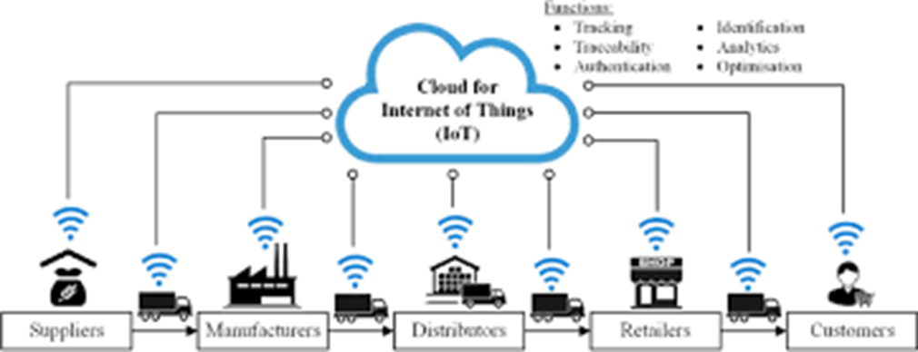
Block Chain in Logistics: Blockchain is one of the world's fastest-growing disruptive technologies, exhibiting an average CAGR of 60% for the next decade. (Compound Annual Growth Rate)
In logistics and supply chain management, blockchain can reduce costs by 90% and improve time savings. It can also create a shared, immutable ledger that records all the transactions and movements in the supply chain. This can help stakeholders track the product journey from origin to destination, improving traceability and transparency. Furthermore, blockchain can help reduce fraud, build trust, and increase supply chain efficiency, which is critical for any enterprise.
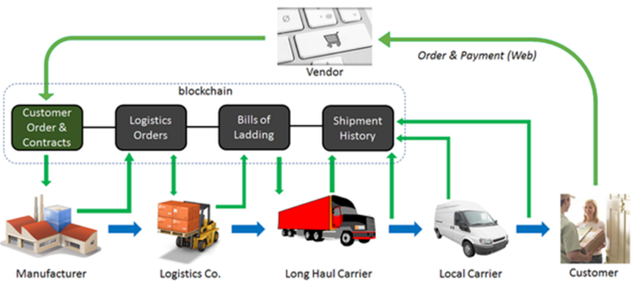
Artificial Intelligence in Logistics: The logistics industry has been transformed by artificial intelligence. The following are four ways artificial intelligence-driven technology can help firms improve and reinvent their logistics.
- Self-Driving Vehicle - Self-driving cars will shorten delivery time and reduce shipping costs by autonomously transporting goods from factories, retail locations, and distribution centers to their destinations.
- Robotics -- In general, robots can do routine tasks such as delivery, transportation, storage,
picking, packaging, and routing.
- Big Data -- Using AI-driven data analytics, organizations can account for variables such as
fleet maintenance schedules, vehicle sensors, adverse weather, and fuel costs. It gives drivers critical data pointers and assists them in travelling more efficiently, and enables businesses to decrease their logistical expenses.
Benefits of Metaverse Logistics: For logistics companies, the metaverse will open up new ways to connect and collaborate, with the potential to synergize operations across your whole supply chain, increasing the overall accuracy, flexibility and efficiency of your logistics business profound impact on business, creating new opportunities for growth, collaboration, and innovation.
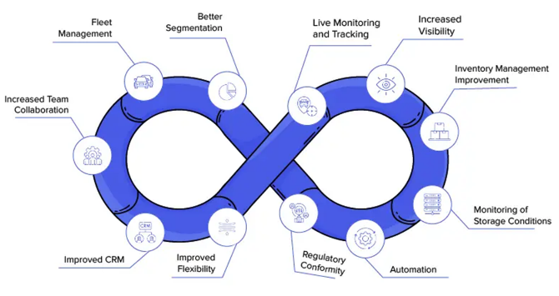
- Connecting the “RIGHT” – Metaverse brings all the concerned channel partners on one common virtual platform, say for example the suppliers and the customers. This also helps every one the demand-supply positions, through digital transformation from unknown to knowable demand fully. This is a collaboration room to understand demand forecasting, purchasing, identifying shipping delays etc.
- Create own environment – Metaverse creates own design and environment to benefit the people seamlessly with digital integration, digital navigation, with “Real Time” updates.
- Data to meaningful information – The metaverse helps the enterprises to convert the raw data into meaningful information with the help of information systems.
- Data driven solutions – With the high rate of converting data to meaningful information, the organizations and the managers are able to take data driven decisions.
- Redefining the supply chains – With the proper integration, interaction, interfaces the organizations can now leverage with the new and improved supply chain processes making their supply chains more efficient and result oriented.
Conclusion: With Metaverse the supply chains are now more agile, resilient, and growth oriented in these volatile times. The network and the design help the enterprises to sustain in the period of changing business environment and possibilities of disruptions.

