How to overcome that fear of stock audits?
What is stock audit? To comply with quality management standards, every company tries to incorporate few positive changes in their processes. Many businesses are getting certified for some specific standard suitable to their industry. Needless to say, before getting certified the companies undertake few internal audits. After reviewing the shortfalls found in the audit, management ensures to overcome the same by improving upon and changing few processes, impart training, or enhance few skill sets to the workforce.
The sole purpose of stock audits are to ensure the declared stocks comply with the physical inventory in the stores. The stock audit or inventory audit refers to the physical verification of raw material, assets, machineries, equipment’s, tools jigs, moulds, etc with the book stock. Top management demands to see business benefits from such audit and demands to see opportunity for improvement for each and every individual involved in the audit.

Stock audit comprises of
- Physical verification and counting of inventories
- Comparison of physical and recorded stocks
- Check inward and outward stock movements
- Audit of stocks lying at outside locations
- Identify slow moving, dead stock, scrap, or damage inventories
- Scope for seeking third party opinion for improvements
- Arranging the inventory in the best possible way
- Verification of all stock ledgers and other records like inward register and outward register.
- To seek confidence on the present process of stores and inventory management.
- Reporting of stocks got damaged, obsolete and shortfalls in the count or discrepancy
- Valuation of stock
- Reconciliation and correcting the entries
Benefits of stock audits
- Internal audits helps to prepare and makes us ready for the external audit.
- Audit findings help the concerned to improve upon the systems, & the process.
- All non-conformances are discussed, reviewed and resolved.
- Adds value to the operations
- Brings systematic and disciplined approach in managing the risk involved in stores.
- Helps in better financial reporting
- Safeguarding various assets, equipment’s, machines etc in the company
Common errors found during audit
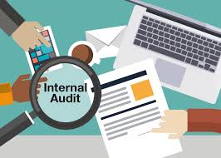
- Inward entry missing
- Outward entry missing
- Receipts and Issues not entered
- Wrong physical counting
- Wrong selection of item while posting the entries
- Selecting a wrong item code
- Audit by incompetent person
- Incorrect time and location
- Improper ventilation and lighting
- Lack of manpower for counting, loading and unloading.

Why that fear does exists?
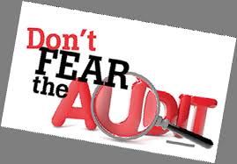
- Myth that audit definitely poses a huge problem.
- Unknown fear of facing the audit or issues
- Not competent enough to read and understand the financial reports
- Fear of loss of job, no promotion, no incentives etc.
- Fear of disclosure of wrong doings.
- Fear of getting loaded with extra work or uninvited work, post audit findings
- Complying with audit requirements seems not possible
- Audit done with intention to find out something wrong.
- The staff is not properly trained to face the audit.
- Sometimes failure is taken at individual level instead of looking it as collective failure.
- Fear of issues getting escalated at a higher level sometimes when not needed.

How to get rid of fear about the stock audit or surprise audit? 
- MATERIAL INWARD BOOK (MASTER BOOK)
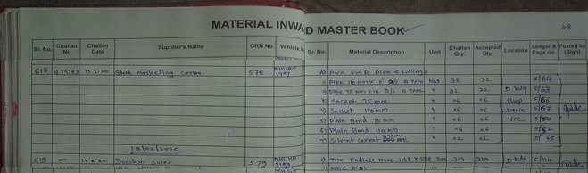
- MATERIAL STOCK REGISTER
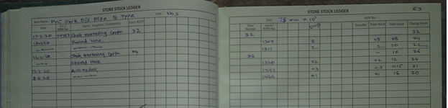
- MATERIAL ISSUE SLIP
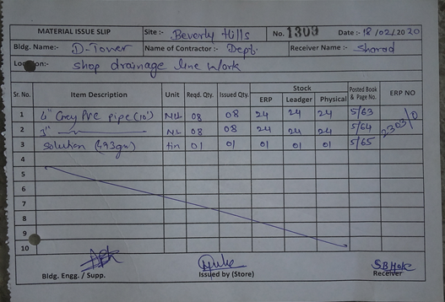
- While making a receipt entry in Stock ledger ensure to write the physical stock figure’s against ledger stocks, and ERP stocks.
- Post making of the receipt entry ensure to take the physical stock.
- After the issue of materials ensure to write the physical stock along with stocks in ledger, and ERP stocks.
- Every time you issue the material, ensure to take the physical stock.
How will this help?
In short if physical counting if done while putting that item inside the bin, as well at the time of physical issue will help to overcome the fear of audit.
The items if found any discrepancy, will get reconciled at the same of receipt or issue, or at least will get reconciled on the same day.
This activity of frequent checking and verification will boost the confidence of the stores staff on the accuracy level.
Practicing this on regularly basis will eliminate the unknown fear of facing audit
Routing physical verification will keep the records always correct.
Having correct records of stocks will also motivate the staff in stores dept to enjoy the work and face the audit.
Such employee engagement will improve the productivity and efficiency in stores dept.
Staff working in stores dept. will continue to be associated for a longer duration.
Here I feel the auditor, the company, and the stores staff shall remember that audit is not to find out who is right or who is wrong, but to find out what shall be right and what is wrong.

