Enhancing performance efficiencies with Up skilling and Re skilling

Nitin Athavle
General Manager,
Rachana Lifestyle, Pune
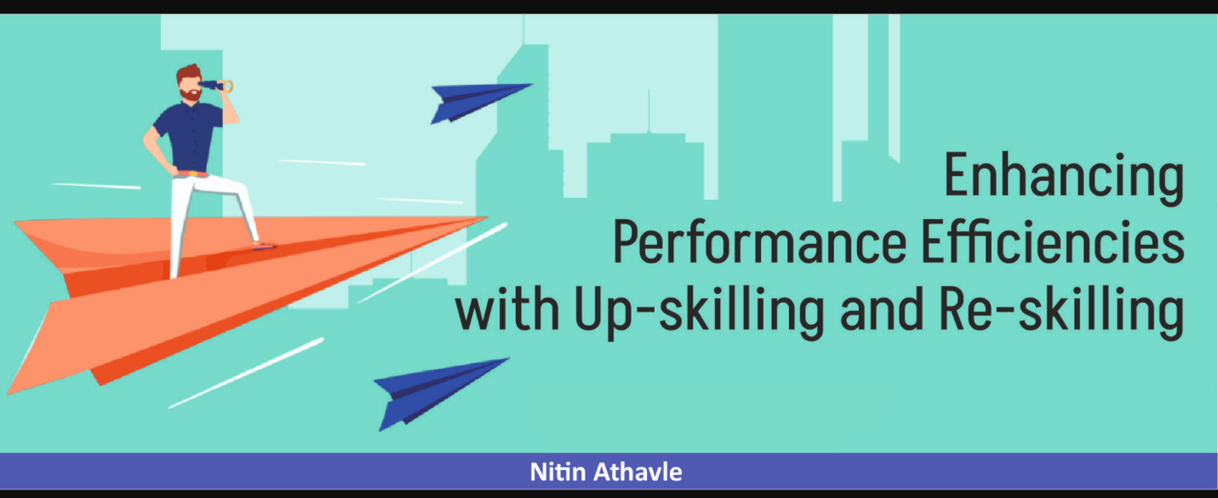

Need for up skilling and reskilling:
In present scenario the business world is changing rapidly. The internal and external factors are impacting business environment to a larger extent. The fiercely competition and the technological advancements are prompting the organizations to restructure, redesign, and reframe in their respective innovative ways. This creates good potential to impart knowledge and train Genx to be more sustainable with competitive edge, by up skilling and re skilling.

Understanding up skilling and reskilling: 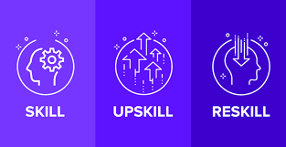

Now improving efficiencies is of prime importance and crucial at work place. Enterprises are no focusing more on providing right skill and knowledge to adopt new technologies and help them to more productive at work stations.
Up skilling enables the work force to get trained with new skills and move upward & forward and contribute more in the organization. Up skilling focusses more upon improving the present skills and knowledge, enabling employees to take new roles and responsibilities in the present organization.
Re skilling helps the employees to become more valuable and start focusing more upon driving themselves towards training collogues, and work partners also to excel in the respective work. Re skilling enables the employees to learn new set of skills and knowledge due to change in job roles.

Approach: There is a wide acceptance towards the idea of enhancing performance efficiencies through up skilling and re skilling across the business world from the traditional approach of change management.

Learnings: The newly joined employees can learn few of the skills like decision making, problem solving, analytical skill, communication skills etc from their senior team members in collaborative working.
Tech-driven Approach: Traditional organization structures are now slowly converting towards learning organizations. Here they create a culture of continues learning and provide to the employees the required and desired skill and knowledge. Another approach is also to integrate AI, & other technologies into their work place to optimize performance.
Skill Gap Analysis: The HR’s need to rightly plan, consider, & conduct Skill Gap Analysis and identify the skill sets needed by the employees.

Skills required for task completion:
During the journey of transformation many individuals and the organizations need to adopt new technologies, for which they require to acquire few skills required to complete the task.
Types of Skill sets
Sr.No. | Education Based | Experience based | Based on Inherent Qualities
1 | Analytical Thinking | Team building | Problem Solving
2 | Professional | Delegation | Getting job done
3 | Management | Negotiation | Managing within the available resources
4 | Leadership | Job/Trade | Motivation
5 | Social | Labor management | Personal trait
6 | Strategical | Decision making | Interpersonal
7 | Soft & Hard | Communication | Life-work balancing

Benefits:
Improvement in Efficiency, Effectiveness, and Productivity.
More involvement, and engagement of the work force.
Enhanced Quality of people, process, product, service and systems together.
Employees are better prepared to deliver.
Foster innovation in the organization

Efficiency through skill & knowledge: Skill is an ability to perform well. Knowledge comes from theoretical & practical experience gained through learnings. Strong foundation of correct understanding, information and right application of knowledge is the key towards success.

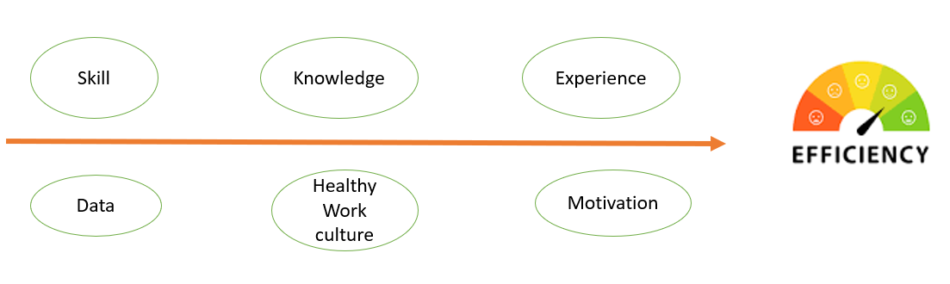

Skill & Competency metrics: Every individual and the organization shall figure out the skill & competency framework and decide the parameters to measure and evaluate the level of skill & competency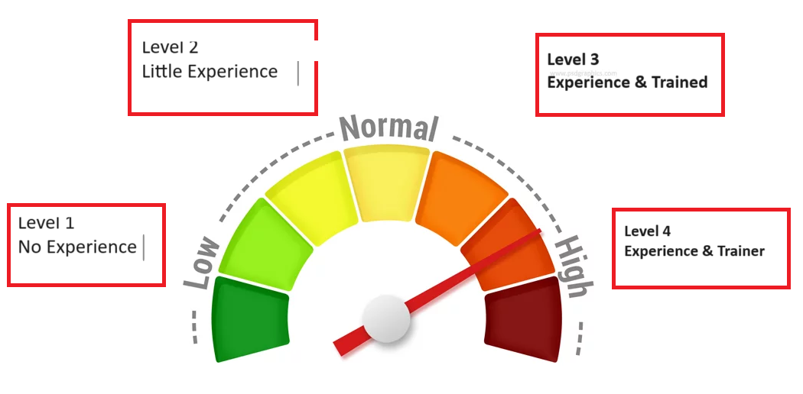

Level of proficiency:
- Level 1-No experience
- Level 2-Little experience
- Level 3-Experience & Trained
- Level 4-Experience & Trainer
Measurements: -
- Does the individual input match the organizational objective?
- Is performance evaluated in real terms after training?
- Is the employee able to handle the job independently?
- Is the employee competent to support in big tasks?
- Can the employee handle the crucial stage?

How to improvise the efficiency?
- Learn & listen – develop habit of learning every day.
- Build confidence with acquiring correct knowledge.
- Surround yourself with good mentors/advisors for guidance.
- Assess strength and weaknesses positively and improve.
- Training and development.
- Overcoming fear of failure.

Future Trends in up skilling & re skilling: Now onwards the work force shall be continuously and consistently be engaged with acquiring new skill sets and upgrading the present skill level.
Organizations shall now focus on technological advancements to keep pace with changing businesses. The survival of the organizations shall be more dependent on how effectively they utilize these technologies.
Hence forth the companies shall be functionally viewed as “Data Driven Decision Companies”.
Training employees with Advance Automation shall be key factor towards bringing competitive edge in the market.

