Digital Organization
(Bringing Organizational change with Business Intelligence)

Change Management?
Change is inevitable. With changes in the business environment, changes in demand & supply patterns, ever changing consumption patterns, spend patterns, sudden inflation, etc. business organizations are transforming into digital business organizations. This has been made possible to them with the help of building information systems. In fact, nowadays such business organizations focusing more upon improving the business intelligence.
Change management is the systematic approach and application of knowledge, tools and resources to deal with change. It involves defining and adopting corporate strategies, structures, procedures and technologies to handle changes in external conditions and the business environment. Organizational change is the movement of an organization from one state of affairs to another.
Impact of Change on the organizations?
When change is positive, the efficiency and productivity of the organization are increased, facilitating the achievement of the organization's goals and mission. Individual and group morale are improved and there is an overall sense of cohesion and well-being.
Organizational change?
Organizational change may be introduced in a variety of ways — new technology, new resources to deal, new organizational structures, change in Mission, vision and strategy, Or company’s structure, policies, procedures, & culture. Change management is the systematic approach and application of knowledge, tools and resources to deal with change. It involves defining and adopting corporate strategies, structures, procedures and technologies to handle changes in external conditions and the business environment.

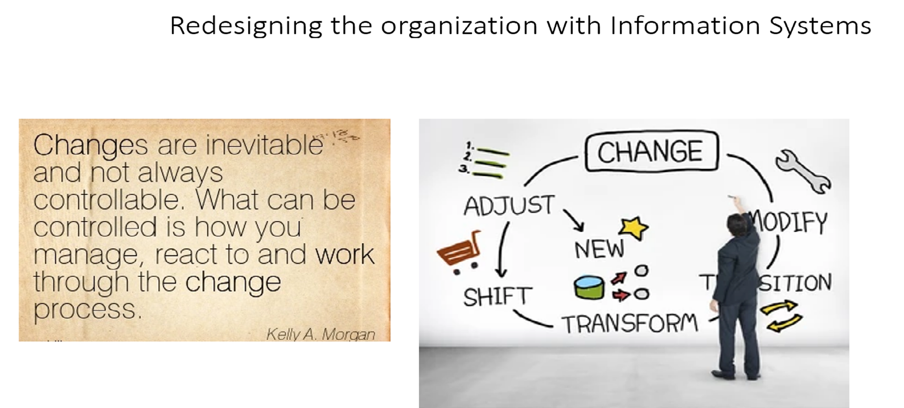

Understanding the organizational change
Questions which need to be addressed while changing business organizations:
- What is changing?
- Why is it changing?
- How will it affect our operations?
- How will it affect the present internal & external business environment?
- How will be the stake holders made aware about the change?
- How do we improve communication & boost trust between the management and employees?
- Identifying and mitigating risks.
- Enhancing employee & customer satisfaction.
- Improving employee skills and proficiency through change-related training initiatives.
Process of Digital Transformation

Digital Transformation process?
Step 1-- Digitization –
- Gather all the documents you want to digitize. Get Organized.
- Make use of the Scanner
- Or Scan with a Mobile App.
- Scan Old Photos with Your Phone.
- Now Protect and Safely Store Your Uploaded Files.
Step 2 -- Organizing/Data Management
- Store all the Digital Documents
- Use may use Windows libraries to store documents on hard drive.
- You still can store your documents in the cloud via a service like Google Drive, or OneDrive.
- Backup your documents to external storage hardware like removable hard drives.
Step 3 -- Automation – Use of E Forms
A) To the best possible extent try to automate certain processes or process by using the digital technology and AI tools. A wide variety of business processes and activities can be automated with/partial human intervention at strategic points within said workflows.
B) Use of Electronic forms--At its simplest, electronic forms are an online version of your paper forms. Essentially, this can be a paperless version of the document with a small amount of automation. This reduces the physical paperwork required in the office and automatically ensures the safe storage and retention of your data.
In a more complex system, an electronic form in combination with cloud technology can be used to send forms into an approval workflow, automate notifications, or set off additional actions that connect to other business processes in your organization.
Streamlining/Transparency/Visibility
- Streamlining is the process used to simplify or eliminate unnecessary work-related tasks to improve the efficiency of processes in businesses or organizations.
- Transparency assists strategy fulfillment and social responsibility. Transparency implies communication and accountability, making it easy to see the actions performed.
- Visibility provides insight into data, making it available to stakeholders
Innovation and Technology
It is adopting technology to support your business goals. It is application of digital technology to existing business problems.
Essential Digital Transformation Technologies;
- Artificial Intelligence (AI)
- Augmented Reality (AR)
- Drones.
- Internet of Things (IoT)
- Robotics.
- Virtual Reality (VR)
- 3-D Printing.
How do Digital Organizations look like?
What does a digital organization look like? The 5 D’s
Now a days Digital organizations are more efficient when they: have a clear business strategy and organizational goals so that teams can make consistent, effective decisions without having to escalate things for senior attention. Also, they experience a free, and fast flow of information within and between teams — operating as a network rather than a hierarchy
Digital transformation enables enterprises to take advantage of modern technologies that allow them to improve customer experiences, automate processes, and help employees become more productive. This strategy is necessary for companies that do not wish to fall behind their competition. The 5Ds are the opportunities for brands to interact with their customers and learn more about them. They include:
Digital Devices – The Businesses must consider all the necessary devices that their audience uses to reach out to them, including a combination of connected devices such as smartphones, computers, gaming consoles, etc.
Digital Platforms – The Businesses must understand the platform that they’ll use to find their right target audience – for ex social media platforms such as Facebook or search engines such as Google?
Digital Media – Here u need to identify what type of media does each platform support and to what extent? Will they be paid, earned, or owned communication channels? How will you craft your message?
Digital Data – Every business and marketing strategy data driven. This could be in the form of market research, campaign analytics, and any data gathered through IoT devices.
Digital Technology – There must be some form of marketing automation software that businesses use to create interactive experiences.

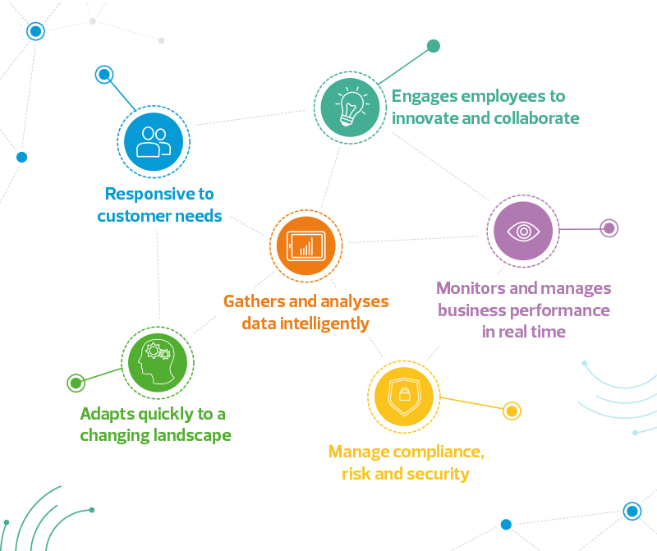
To conclude:
“You can’t delegate digital transformation for your company… You and your executives have to own it! Executives need to engage, embrace and adopt new ways of working with the latest and emerging technologies.”
— Barry Ross, Ross & Ross International

